
National University Of Modern Languages, Islamabad

User Experience Design (UXD)

Lab Task 13
Task: IBM website evaluation

Name: Zulqarnain Hassan
Class: 6A Afternoon
Roll no: SP-21379
Assigned Date: 22 May, 2025
Deadline: 22 May, 2025

Marks Obtained
Remarks

Issues:

Evaluation
Match Between System and the Real World:
Issue: The term "AI agents" in the main headline might be a bit abstract for users who are new to the concept. While the sub-headline offers some context, it could be clearer what an "AI agent"

Recommendation:
Consider a concise, perhaps interactive, explanation of "AI agents" directly on the homepage, or link to a quick overview.
User Control and Freedom:
there isn't an obvious "undo" or "back" function within the flow presented by the static images.

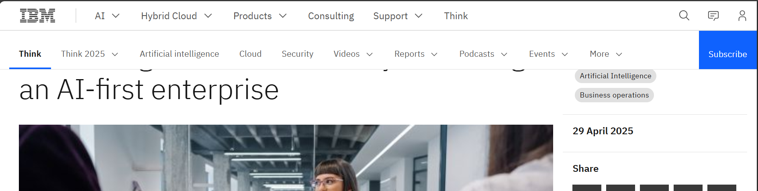
Recommendation
Ensure clear and consistent "back" or "undo" options are available on subsequent pages after a user initiates an action.

Consistency and Standards:
Issue:
The "Latest news" section uses a carousel with small dots for navigation, while the "Recommended for you" section and "Product announcements" are static grids or lists.
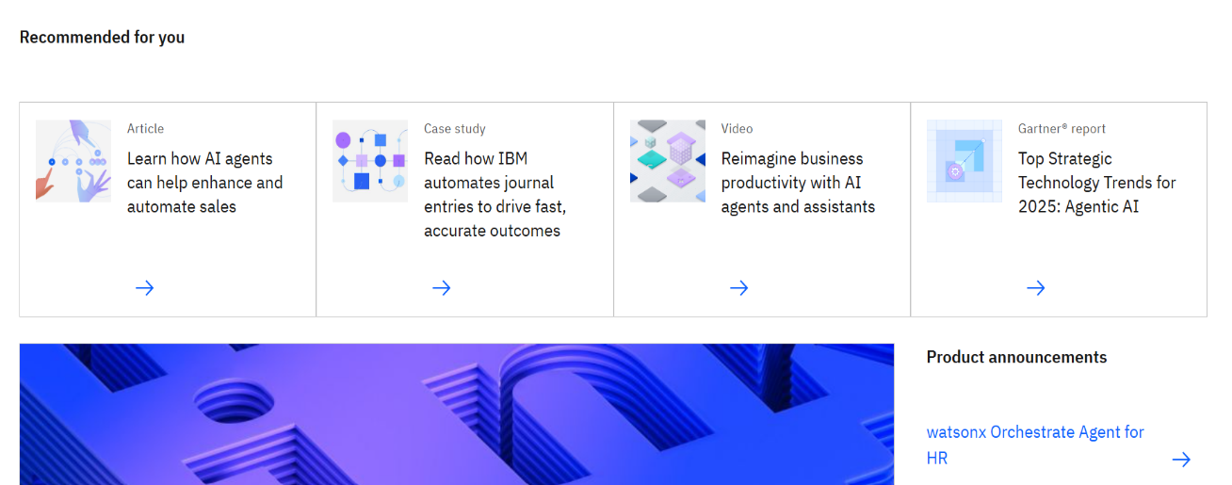


Recommendation:
consistent display method for news and recommended content would improve predictability for the user.

Recognition Rather Than Recall:
Issue:
some of the specific product names under "Product announcements" (e.g., "watsonx.data," "LinuxONE") might require users to recall what they are, rather than immediately recognizing their function from the name alone
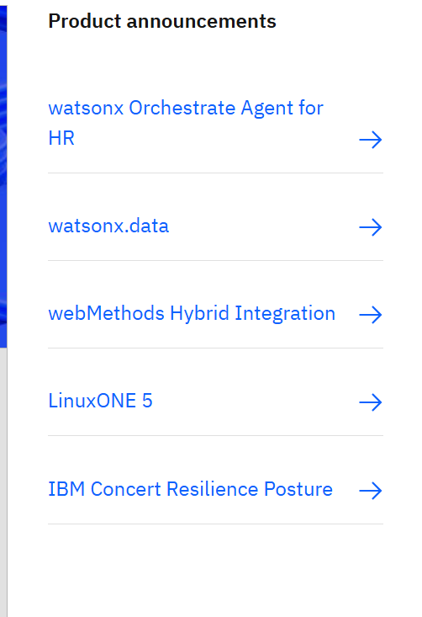

Recommendation:
For less common product names, consider brief descriptive text or tooltips on hover to aid recognition
Flexibility and Efficiency of Use:
Issue:
For power users who might want to quickly access specific product information, the primary navigation at the top is comprehensive but doesn't immediately offer quick links to all products from the homepage.


Recommendations:
Consider adding a "quick links"

Aesthetic and Minimalist Design:
Issue:
The page is generally clean. However, the "Latest news" carousel and the "Recommended for you" section, while well-intentioned, add a fair amount of content below the fold. This could potentially lead to information overload for users whose primary goal is to quickly find solutions.


Recommendation:
Consider if some of this content could be consolidated or accessed through a single entry point.
Help Users Recognize, Diagnose, and Recover from Errors:
From the “what’s new “ section there is no any back option or any recover option for ‘Subscribe‘ button if use click by mistakenly.


Recommendation:
Must provide a way to recover form these type of error.

